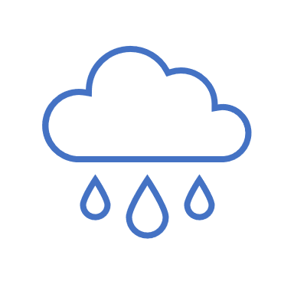
Rai Rain Cloud Activity Les

Objective: Students will learn how clouds form and where water goes after it rains.

Time frame: 30-45 minutes

Supplies (per participant):
Vase or clear container (a large clear, plastic cup will also work, depending on the number of participants)
Measuring cup containing approximately 2 cups of water
Pitcher with 2 cups of water
Food coloring (blue or color of your choice)
Eye dropper or straw
Shaving cream
Paper towels or towels

Directions:
- Pour water from the pitcher into the vase or clear container.
- Add shaving cream on top of water in container. Note: more shaving cream will require more “raindrops” before the “rain” begins to fall.
- Put food coloring into the measuring cup containing approximately two cups of water. Stir.
- Using an eye dropper or straw, add “raindrops” on top of the cloud. Squeeze dropper bulb and then insert dropper into the colored water. Release the bulb and lift the dropper out of the liquid. Squeeze to add “raindrops” to the top of the cloud. If using a straw, place straw vertically into water, place fingertip over top, and lift the straw out of the water. Release “raindrops” by lifting fingertip. (Note: the instructor should demonstrate to students how to use the eye dropper or straw.)
- Repeat until rain begins to fall from the cloud.

Discussion questions:
- What do we call the fluffy clouds that become storm clouds? (Cumulus nimbus clouds)
- How does lightning form? (a buildup of static electricity within the atmosphere)
- Where does rain go as it washes down street? (Storm drains)
- Where does the storm drain empty? (Creeks and rivers)
- Why should we be careful about trash outside?

Find more children’s activities at www.waterone.org/kidzone

